Topic 4.8

AMINO ACIDS

Structure
Acid-Base Properties
Condensation Reactions
Proteins

STRUCTURE OF AMINO ACIDS

Amino acids are molecules containing an amine group and a carboxylic acid group. Naturally occurring amino acids have the following general formula:

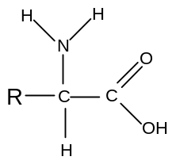
There is a central carbon atom attached to a hydrogen, a carboxylic acid group, an amine group and an alkyl group. Amino acids are thus all chiral except for glycine, in which the R is another H atom.

Amino acids occur widely in nature and have a number of uses in the human body. Some simple examples are:

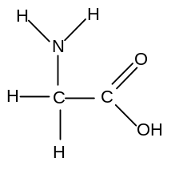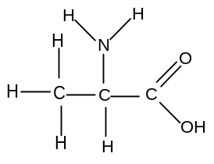
glycine alanine
aminoethanoic acid 2-aminopropanoic acid

ACID-BASE PROPERTIES OF AMINO ACIDS

Carboxylic acids have acidic properties and react with bases.
Amines have basic properties and react with acids.
It therefore follows that amino acids have both acidic and basic properties.

i) reaction with bases

Amino acids react with strong bases such as sodium hydroxide:

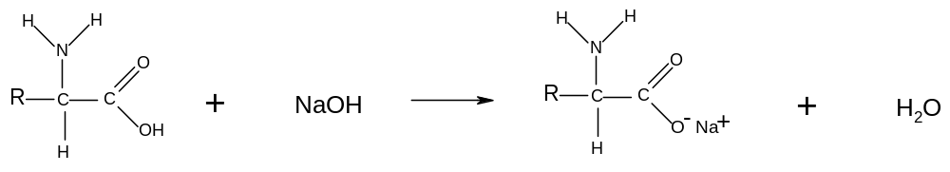
In high pH, therefore, amino acids exist in anionic form:
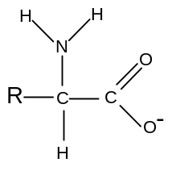

ii) reaction with acids

Amino acids react with strong acids such as hydrochloric acid:

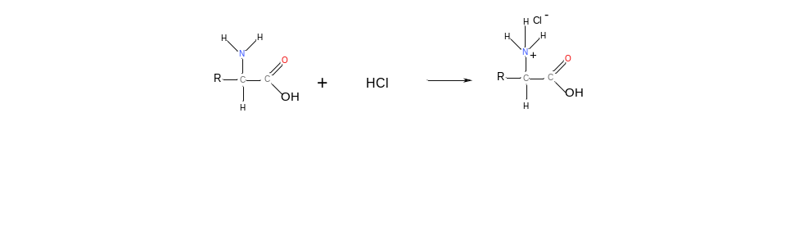
In low pH, therefore, amino acids exist in cationic form:
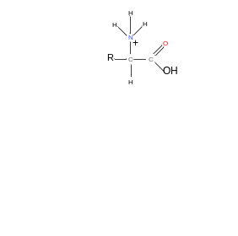
iii) reaction with itself

Since amino acids have a proton donating group and a proton accepting group on the same molecule, it follows that each molecule can undergo an acid-base reaction with itself:
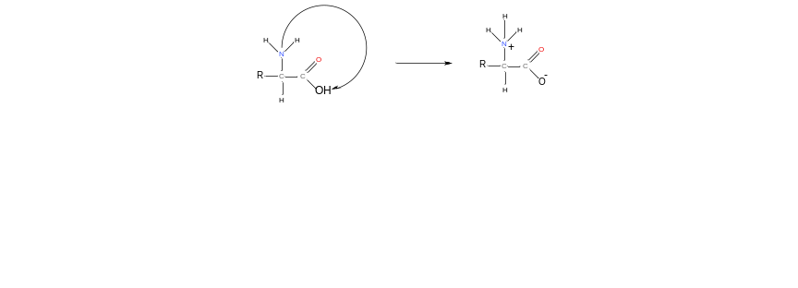
The double ion that is formed as a result of this reaction is called a Zwitterion. This reaction happens in the solid state.

In the solid state, therefore, amino acids are ionic. This explains why they are solids with a high melting point.

iv) summary

Amino acids can exist in molecular form, in cationic form, in anionic form or in Zwitterion form depending on the environment:

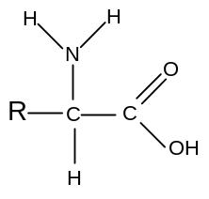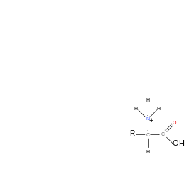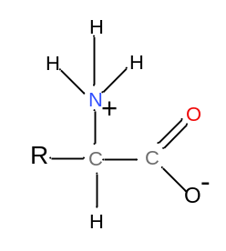
in neutral solution in alkaline solution in acidic solution in the solid state

Since amino acids can react with acids and alkalis, they make very effective buffer solutions.

CONDENSATION REACTIONS OF AMINO ACIDS

Amines undergo condensation reactions with acyl chlorides and acid anhydrides.

Carboxylic acids are less reactive than acyl chlorides and acid anhydrides but can still undergo a similar reaction with amines under certain conditions inside living organisms.

Since amino acids have both acid and amine groups, two molecules can therefore react with each other to form a molecule containing a peptide or amide link:

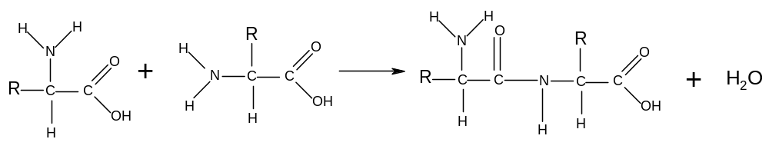
This reaction is called a condensation reaction because two amino acid molecules join together and one molecule of water is eliminated.

The resulting molecule is called a dipeptide.

Dipeptides can also be formed by the condensation of two different amino acids. In this case two different molecules can be formed:

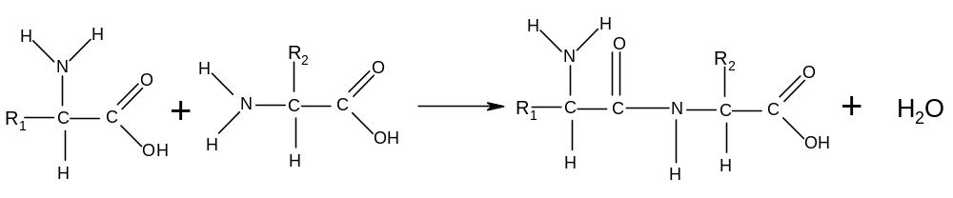
or
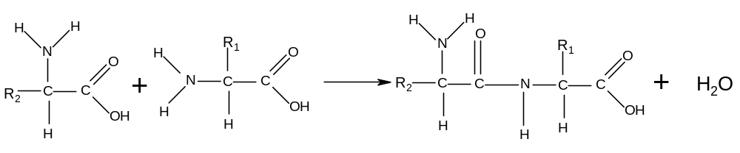

Since the resulting dipeptides also have both amine groups and carboxylic acid groups, they can undergo further condensation reactions, eventually forming polymers:

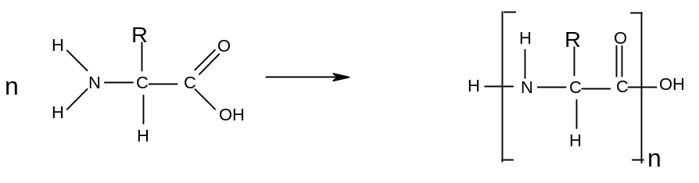
This reaction is carried out alongside DNA molecules in the bodies of living organisms. The DNA lines up the amino acid molecules in the correct order so that the condensation reactions can take place. The resulting polymer is called a protein, and is an essential component of living organisms.

PROTEINS

Proteins are naturally occurring polyamides formed by the condensation of many amino acid molecules under carefully controlled conditions around the DNA backbone.

i) structure

The sequence of amino acids in a protein is known as the primary structure of the protein. It varies from protein to protein, depending on the function that the protein needs to perform.

Eg: gly – ala – leu – iso – gln
(each of these three–letter symbols is the code for an amino acid)
A protein can have several thousand amino acids, all arranged in a specific order.

Protein molecules are not straight as there is hydrogen bonding within the molecule; the hydrogen atom on one peptide link can form a hydrogen bond with the nitrogen or oxygen atoms on another peptide link; causing the structure to coil up:

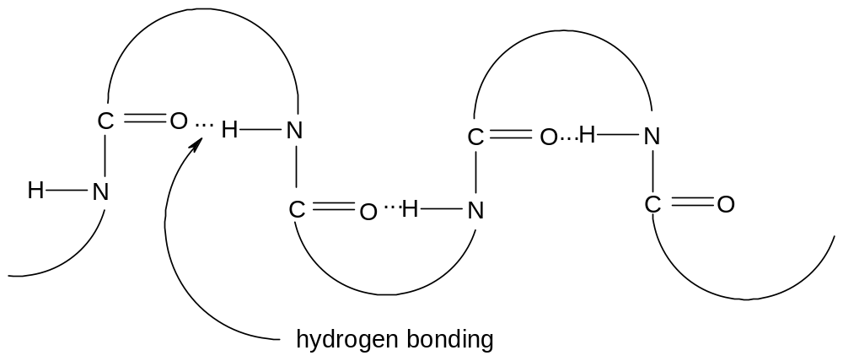
The result of this coiling is a helical structure known as the secondary structure of the protein.:

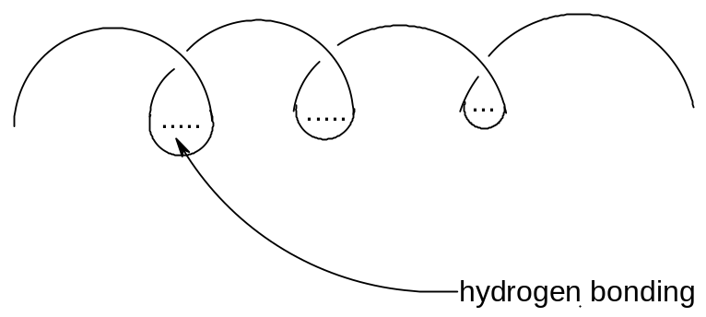

ii) hydrolysis

The peptide link in proteins is the same as the peptide link in N-substituted amides. As a result it can be broken by heating in strong acid or strong alkali.

Proteins can thus be broken down into their constituent amino acids by heating in strong acid or strong alkali; in practice 6 moldm⁻³ HCl is generally used.

This reaction is an example of a hydrolysis reaction. In acidic conditions the amino acids are produced in cationic form:

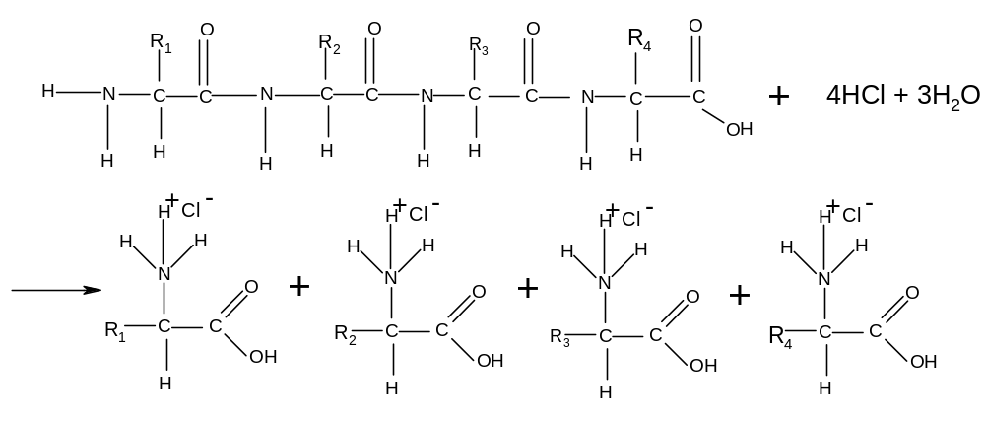
This hydrolysis reaction enables chemists to deduce which amino acids are present in a sample of protein. The different amino acids can be identified by chromatography.

If a sample of the amino acid mixture is placed onto chromatography paper and allowed to separate, it is possible to identify the different amino acids present in the sample by comparing their R_{f} values (the distance each amino acid moves up the paper compared to the solvent) with those of known amino acids.

Type of reaction | Mechanism
1. acid-base reactions of amino acids  a) with acids  reagents: HCl  conditions: room temperature  equation: R-CH(NH₂)-COOH + HCl → R-CH(NH₃⁺Cl⁻)-COOH  b) with alkalis  reagents: NaOH  conditions: room temperature  equation: R-CH(NH₂)-COOH + NaOH →R-CH(NH₂)-COO⁻Na⁺ + H₂O  2. condensation reactions of amino acids  conditions: DNA  equation: n R-CH(NH₂)-COOH → H-(NHCRHCO)_{n}-OH + (n-1) H₂O  3. hydrolysis of proteins  reagents: 6 moldm⁻³ HCl  conditions: heat, reflux  equation: H-(NHCRHCO)_{n}-OH + (n-1) H₂O + n HCl → n R-CH(NH₃⁺Cl⁻)-COOH | Nucleophilic addition-elimination  (not required)

